**بسمه تعالی**

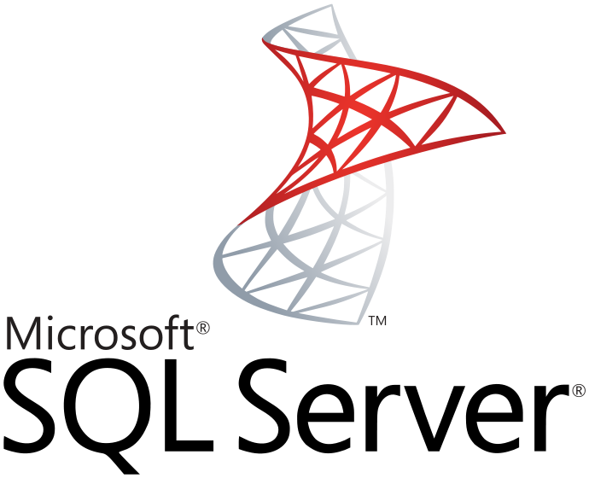

برنامه نویسی بانک اطلاعاتی SQL Server

**نویسنده : محمد حسین فخرآوری**

بررسی فعال سازی change tracking روی دیتابیس

|  |
| --- |
| SELECT CASE WHEN CHANGE_TRACKING_CURRENT_VERSION() IS NULL THEN 'not enabled' ELSE 'enabled' end |

فعال سازی روی دیتابیس

|  |
| --- |
| ALTER DATABASE Fakhravari  SET CHANGE_TRACKING = ON  (CHANGE_RETENTION = 2 DAYS, AUTO_CLEANUP = ON) |

* تغیرات را هر 2 روز پاک سازی میکند

فعال سازی روی جدول

|  |
| --- |
| ALTER TABLE [Table1]  ENABLE CHANGE_TRACKING  WITH (TRACK_COLUMNS_UPDATED = ON) |
| EXEC sys.sp_MSforeachtable N'ALTER TABLE ? ENABLE CHANGE_TRACKING WITH(TRACK_COLUMNS_UPDATED = ON)' |
| * لیست جداولی که Change Tracking روی آنها فعال نیست   SELECT N'ALTER TABLE '+full_table_name+N' ENABLE CHANGE_TRACKING'+CHAR(13)+CHAR(10)  FROM  (  SELECT QUOTENAME(s.name)+'.'+QUOTENAME(t.name) AS full_table_name, s.name AS schema_name, t.name AS table_name  FROM sys.key_constraints x  JOIN sys.tables t ON x.parent_object_id=t.object_id  LEFT JOIN sys.change_tracking_tables ON t.object_id=sys.change_tracking_tables.object_id  JOIN sys.schemas s ON t.schema_id=s.schema_id  WHERE x.[type]='PK' AND sys.change_tracking_tables.object_id IS NULL AND t.name NOT IN ('sysdiagrams')    )y  ORDER BY schema_name, table_name |

غیر فعال سازی روی جدول

|  |
| --- |
| ALTER TABLE [TableName] DISABLE CHANGE_TRACKING |
| * لیست جداولی که Change Tracking روی آنها فعال است   SELECT 'ALTER TABLE ['+S.name +'].['+OBJECT_NAME(T.object_id)+'] DISABLE CHANGE_TRACKING' AS TableName  FROM sys.change_tracking_tables T  JOIN sys.tables TT ON TT.object_id=T.object_id  JOIN sys.schemas S ON S.schema_id=TT.schema_id |
| EXEC sys.sp_MSforeachtable N'ALTER TABLE ? DISABLE CHANGE_TRACKING' |

گرفتن مقدار آخرین تغیرات

|  |  |
| --- | --- |
| SELECT CHANGE_TRACKING_CURRENT_VERSION() AS InDatabse | **آخرین مقدار دیتابیس** |
| SELECT CHANGE_TRACKING_MIN_VALID_VERSION ((SELECT OBJECT_ID('Warehouse.Afrad'))) AS InTableAfrad | **اولین مقدار** |
| SELECT CT.SYS_CHANGE_VERSION FROM CHANGETABLE( VERSION Warehouse.Afrad, (Id), (Id)) AS CT | **آخرین مقدار** |
| SELECT CT.*, f.*  FROM CHANGETABLE(CHANGES Warehouse.Afrad, 0) AS CT LEFT JOIN Warehouse.Afrad f ON f.Id=CT.Id | |

تشخیص داشتن تغیرات جدید

|  |
| --- |
| DECLARE @prevTrackingVersion INT=0;  DECLARE @trackedTables AS TABLE(name NVARCHAR(1000));  INSERT INTO @trackedTables(name)  SELECT '['+S.name+'].['+OBJECT_NAME(T.object_id)+']' AS TableName  FROM sys.change_tracking_tables T  JOIN sys.tables TT ON TT.object_id=T.object_id  JOIN sys.schemas S ON S.schema_id=TT.schema_id;  DECLARE @changedTables AS TABLE(name NVARCHAR(1000));  DECLARE @tableName NVARCHAR(1000);  WHILE EXISTS (SELECT TOP 1 * FROM @trackedTables)  BEGIN  SET @tableName=(SELECT TOP 1 name FROM @trackedTables ORDER BY name ASC);  DECLARE @sql NVARCHAR(250);  DECLARE @retVal INT;  SET @sql='select @retVal = count(*) from changetable(changes ' + @tableName+', ' + CAST(@prevTrackingVersion AS VARCHAR)+') as changedTable';  EXEC sp_executesql @sql, N'@retVal int output', @retVal OUTPUT;  IF @retVal>0 BEGIN  INSERT INTO @changedTables(name)SELECT @tableName;  END;  DELETE FROM @trackedTables WHERE name=@tableName;  END;  SELECT * FROM @changedTables; |